Steve Datz
Royal Rodents

Gameplay:
- Game Concept
Embark on a side-scrolling, resource-management, city-building, trash-collecting strategy game
- Genre
  - Side-scrolling, Resource management, Strategy
- Target Audience
  - Everyone - E/E10+
- Goal of Game
  - Defeat the neighboring kings and steal their crowns.
  - Complete in the least amount of time (days).
- Look and Feel
  - Cartoony pixel
- Gameplay/Mechanics
  - Build Structures
    - Structure Types:
      - Town Center (Level 0) - holds gathered resources, upgrade town level
      - Houses (Level 1) - Increase max Rodent Pack size
      - Farms (Level 2) - generate food
      - Walls (Level 3) - base defence
      - Towers (Level 4) - base defence, deploy
      - Banners (Level 4) - stat boost to nearby rodent allies
  - Control Your Rodent Pack
    - Assign Them to Build
    - Assign as Soldiers
    - Assign to Occupy Structures
  - Collect Resources
    - Food - used to recruit Rodents to your pack
    - Trash - used for early-game building
      - Locations: Garbage bins, on the ground
    - Wood - used for mid tier building
      - Locations: Trees
    - Metal - used for high tier building
      - Locations: Underground ore
    - Shiny - used to upgrade Town Center level
      - Locations: from completing build structures, RNG drops
  - Recruit New Rodents to Your Pack
    - Give food to convince them to join
    - Number of food for Recruiting depends on rodent species:
      - Rat: 3 Food
      - Badger:
      - Beaver:
      - Raccoon:
      - Mouse:
      - Porcupine:
  - Mischief Meter
    - How much you’ve upset your neighbors
    - A full bar ensures the enemy king himself will march on your territory
- World Map
  - Suburban neighborhood, fenced backyards
  - Backyard Map (add picture)
  - Neighborhood Map (add picture)
- Types of Characters
  - Rat - specialized for fast movement
  - Badger - specialized for melee combat
  - Beaver - specialized for chopping wood(?), building
  - Racoon - specialized for searching garbage, sneaking/stealth
  - Mouse - specialized at tunneling
  - Porcupine - specialized at ranged combat
- Design
  - Color Palette
  - Concept Art
  - Inspiration
    - Kingdom (2015)
    - Fallout Shelter (2015)
    - Clash of Clans (2012)
- User Controls
  - Tapping to move/interact with resources and characters
  - Drag to go left and right
  - Click an object within radius to interact
- Audio
  - Cartoon sound effects
  - Happy music
- Interface
  - User Interface
- Main Screen- Resources, options to other two screens
- Assignment Screen
- World Screen
  - Control System
    - Tapping the screen
    - Click and Dragging rodents
- Internal economy
  - Resource management
    - Wood, Stone, Metal, Food, Trash
- Fighting
  - Increase days = increase wave amount

Win Conditions:
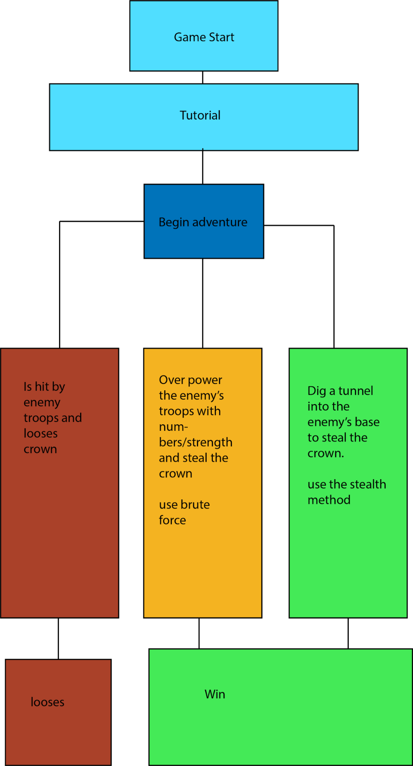

Color Pallette:
Concept:
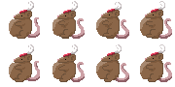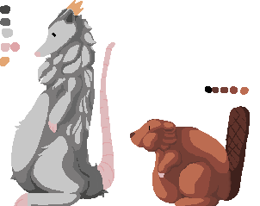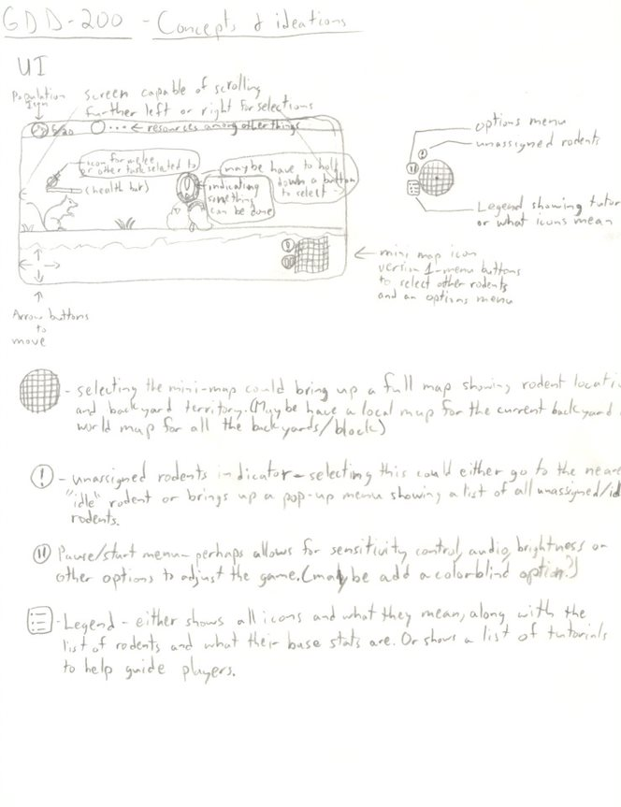
*artist stuff like uisketch , concept art and color palettes *

*Skill and enemy frequency charts*

*insert world map*

*level design images*

